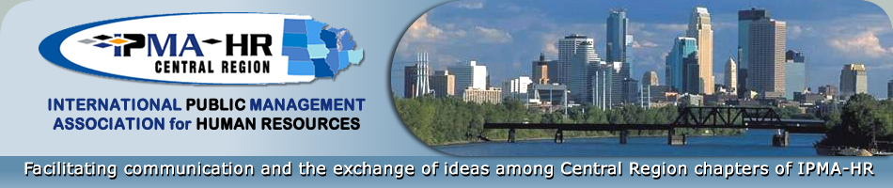

IPMA-HR Central Region
2022 Nomination

BARBARA SUNDQUIST DISTINGUISHED SERVICE AWARD

PURPOSE AND NOMINATION CRITERIA
To recognize and honor one member of the Central Region who has made a significant contribution(s) to the advancement of the Central Region and who, at the time of the award, is:
- Retired and eligible to draw a retirement benefit from a public jurisdiction; and
- Not active on a full-time basis in public personnel in the Central Region.

I nominate the following person for the BARBARA SUNDQUIST DISTINGUISHED SERVICE AWARD:

Name and Chapter (if applicable):
Title: Phone:
Chapter President Name/Phone Number:

Please describe this person's contributions to the advancement of the Central Region below. You may attach additional sheets if needed. Be specific when describing the contributions and their impact to the Central Region.

Submitted by: Date Submitted:
Title/Agency:
Address:
Send nomination form by no later than 4:30 p.m. on Friday, May 13, 2022 to:
Coy Hillstead, Chillste@umn.edu, 2022 Executive Committee
Award Nominations Chair

