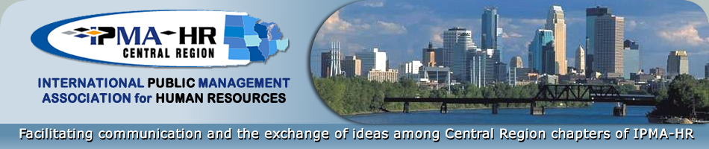

BOARD MEETING AGENDA

Wednesday, April 28, 2021
3:00pm

IPMA-HR Central Region Officers (2020-2021)

President – Jennifer Gabbard

President Elect – Jamie Chism

Treasurer – Eva Lee

Secretary – Christy Mann
Past President – Amy Strough
Executive Council Representative – Amy Blake

Agenda Items

- Call to Order and Welcome

- 2021-2022 Executive Committee
  - Elections
    - President Elect Nominee – Coy Hillstead
    - Treasurer Nominee – Eva Lee
    - Secretary Nominee – Susan Cox
    - Executive Representative – Amy Blake

  - Confirmations
    - President– Jamie Chism
    - Past President – Jennifer Gabbard

- Committee Reports
  - By-law Committee
    - Update Article II, Section III: Nomination Committee to extend the positions of President, Past President and President Elect to 2 year terms.
    - Update Article V, Section III: Tenure of office and removal to extend the positions of President, Past President and President Elect to 2 year terms.

- Board Member Reports
  - Treasurer – Eva Lee
  - Secretary – Christy Mann
  - President Elect – Jamie Chism
  - Past President – Amy Strough

- Adjourn

